11/8/2020

Smart Health Monitoring System for elderly people Using IBM Cloud

DONE BY,

SHANKARA NARAYANAN R.V.

**1 INTRODUCTION  
  1.1  Overview**

 Health monitoring system involves monitoring of patient’s vitals remotely by means of devices that transfers patient data to remote locations wirelessly. It plays a major role in giving quality care for people in rural area  
**1.2  Purpose**

Health Monitoring System provides multiple options to change the traditional management of patients. This reduces the cost of health care to improve the treatment process and provides a remote health monitoring system.

**2 LITERATURE SURVEY  
  2.1  Existing problem**

Health monitoring system for elderly people living is created because they forget the things they do due to their age .  
**2.2  Proposed solution**

Use of Smart Health Monitoring System to regulate temperature and water level to help the elderly people to know their temperature and water level for better living.

**3 THEORITICAL ANALYSIS  
  3.1  Block diagram**

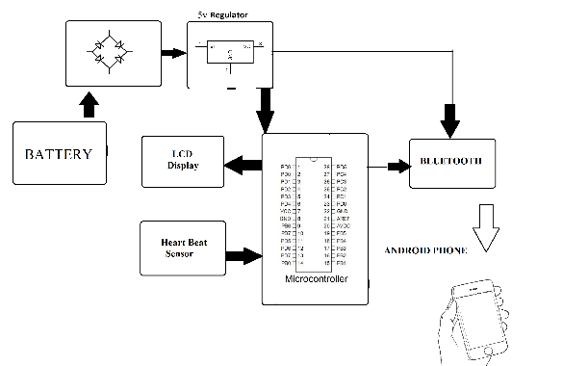

**3.2  Hardware / Software designing**  
Hardware components used are : 1.Smartband 2.Temperature sensor 3.Pulse Rate sensor 4.Connecting wires.

Software components used are : 1.IBM cloud 2.IBM IOT platform 3.IBM Watson 4.node-red 5.Python IDLE 6.MIT app inventor

**4 EXPERIMENTAL INVESTIGATIONS**

Elder people will lead a better and a safer long life.

**5 RESULT**

Smart Health Monitoring for elderly people is created using IBM cloud. **6 ADVANTAGES & DISADVANTAGES**

**PROS:**

- Elderly people can be helped in a short period of time.

**CONS:**  
- It requires a lot of skills in order to manage and maintain an incubator.  
- The incubator requires power source to work. In most rural and remote areas, reliable source of power is a major challenge.

**7 APPLICATIONS**

* Health care [sensors are playing an essential role](https://www.elprocus.com/important-role-of-sensors-in-daily-life/) in hospitals. -
* Associating the gap between the elders and the doctor
* Best to be used in rural areas for multipurpose. So that all the conditions are simply measured
* Operation of this device is very simple
* It gives a good performance.

**9 CONCLUSION**

Smart Health Monitoring using IBM cloud and iot was created and was used for treating elderly people.As the success rate is high, it is highly recommended for use for people who are elder.

**10 FUTURE SCOPE**

With more High-end hardware and software, the smart health monitoring system can be customized and can be upgraded and improved for more efficiency and success rate.

**11 BIBILOGRAPHY**

a.Github

b.ubuntupit

c.youtube

d.smart internz

SCREENSHOTS:





